**Practical 5: Exercise 3.Search conditions, Summary queries, Sub- queries**

**Theory:**

[SELECT](http://localhost:90/phpmyadmin/url.php?url=https://dev.mysql.com/doc/refman/5.5/en/select.html) * from passenger_view

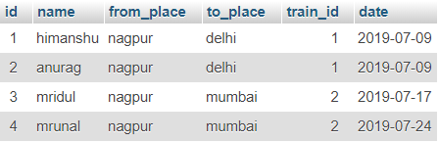

SELECT * from passenger_view WHERE name = 'himanshu'

SELECT max(amount) from payment



[select](http://localhost:90/phpmyadmin/url.php?url=https://dev.mysql.com/doc/refman/5.5/en/select.html) * from passenger WHERE id [in](http://localhost:90/phpmyadmin/url.php?url=https://dev.mysql.com/doc/refman/5.5/en/comparison-operators.html#function_in) ([SELECT](http://localhost:90/phpmyadmin/url.php?url=https://dev.mysql.com/doc/refman/5.5/en/select.html) id from passenger WHERE name = 'himanshu')

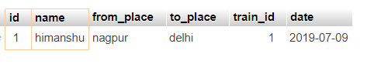

[SELECT](http://localhost:90/phpmyadmin/url.php?url=https://dev.mysql.com/doc/refman/5.5/en/select.html) id,name,from_place,to_place,train_id,[date](http://localhost:90/phpmyadmin/url.php?url=https://dev.mysql.com/doc/refman/5.5/en/date-and-time-types.html),[count](http://localhost:90/phpmyadmin/url.php?url=https://dev.mysql.com/doc/refman/5.5/en/group-by-functions.html#function_count)(*) from passenger_view GROUP by to_place ORDER by id desc

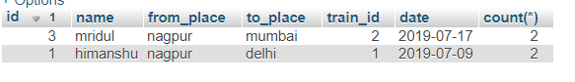

Show the details of thet clerk who has sold the highest amount of ticket

SELECT * from clerk WHERE id in (SELECT clerk_id from payment WHERE amount IN (select max(amount) from payment))

